Feb 9th –108.5 invested got 159.70 so total =309.7

Initial amount-258.5

Corner u-13 50 euros- Won 70 euros

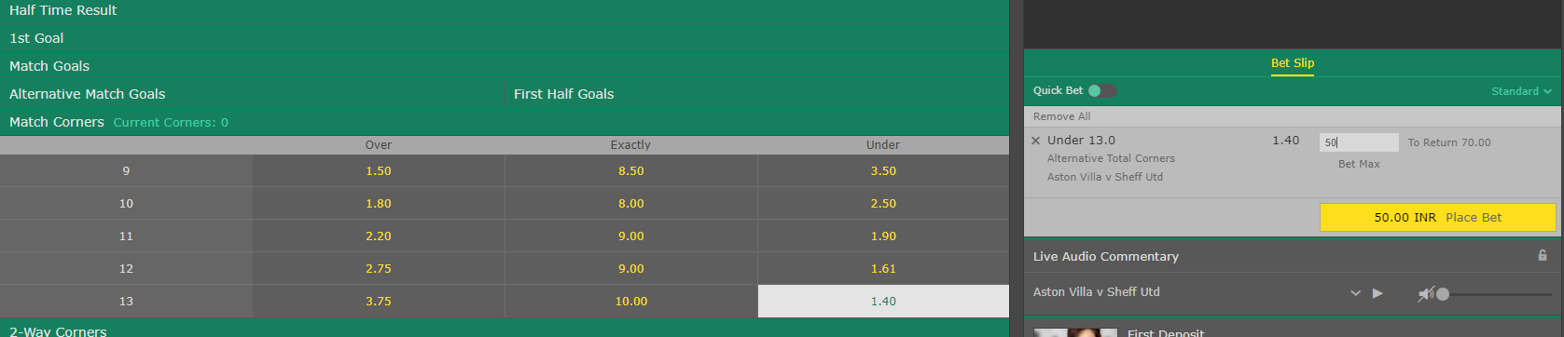

58.5 euro on u13 corners won 89.70

